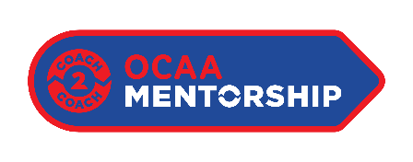
OCAA Mentorship Program – Apprentice Letter of Intent
Please complete the following:
- Name:
- Email:
- Phone:
- Sport:
- Gender:
- Do you identify as a member of the BIPOC community? – Y/N
- NCCP#:

Please answer each question below. (200 words or less per question)
- Tell us about your experience with sport as an athlete:

- Tell us about your experience with sport as a coach or in leadership roles:

- Tell us a little about your interest in coaching, and where you see your coaching journey leading:

- Have you started your coach education journey yet? Please explain:

- Tell us a little about what you hope to achieve through this mentorship program:

- Tell us what you believe may differentiate you and why you want to be part of this program)?

- Please feel free to include any supporting documents (Optional)

